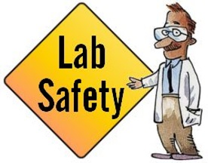
Name:____________________________ Block:_________

Unit Learning Goals:
• Demonstrate appropriate safety techniques and proper use of protective equipment
• Demonstrate skills in measuring and in recording data
• Communicate results and data in clear and understandable forms

Unit Vocabulary
• accuracy
• analysis
• interpretation
• observation
• precision
• SI unit
• significant figures
• unit

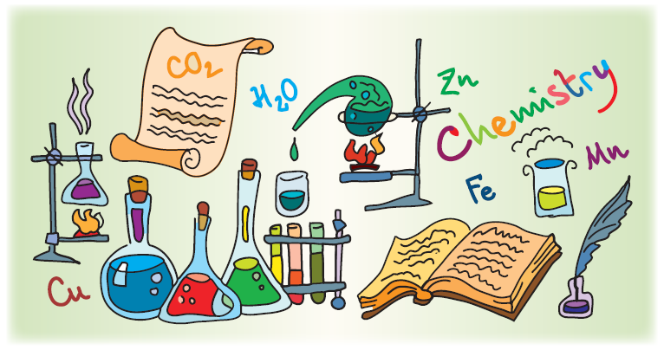
In this unit, you’ll learn about the range of tools, skills, and techniques you’ll be using as you study chemistry.
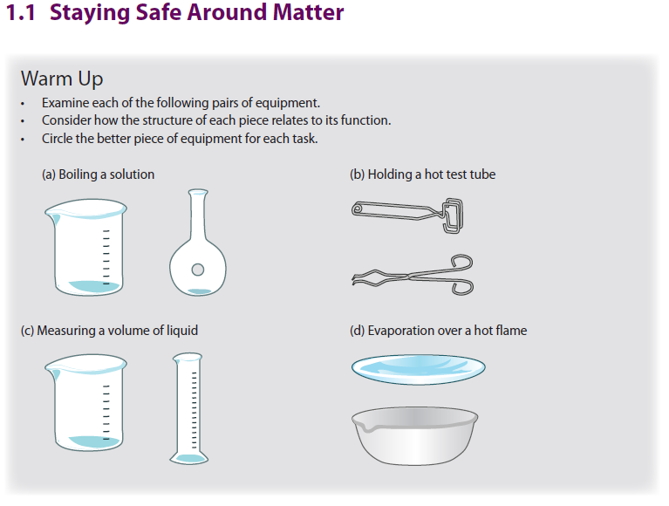
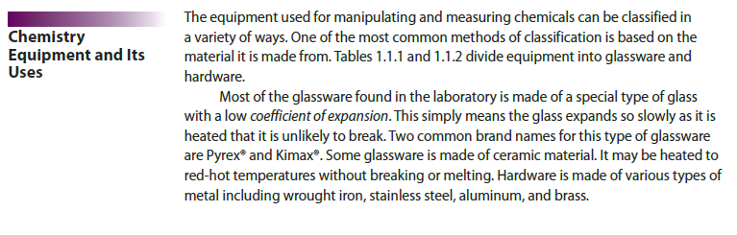

Laboratory Glassware
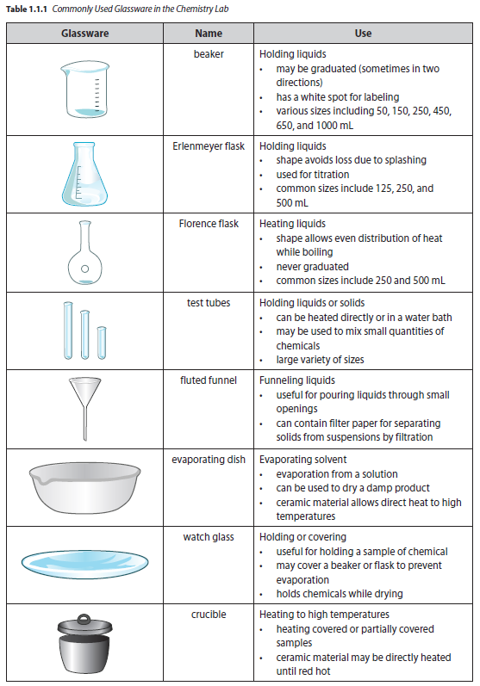
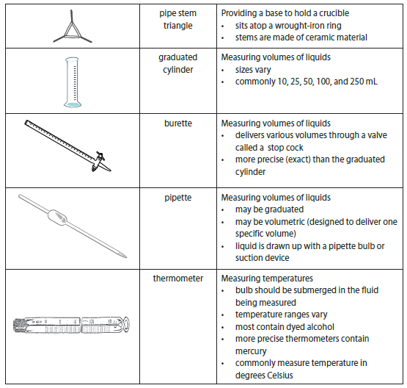
Quick Check
Working with a partner, design a classification scheme and use it to put the glassware into groups according to common characteristics.

Laboratory Hardware:
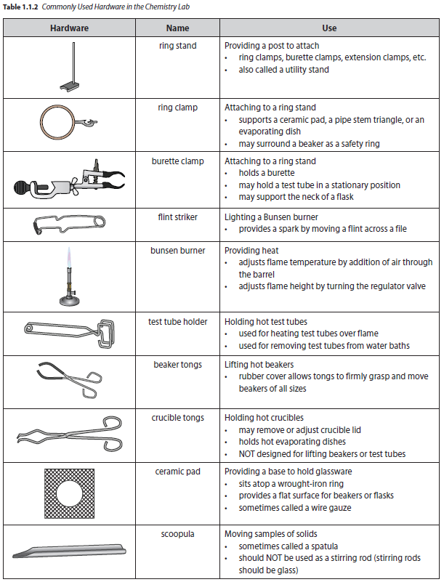

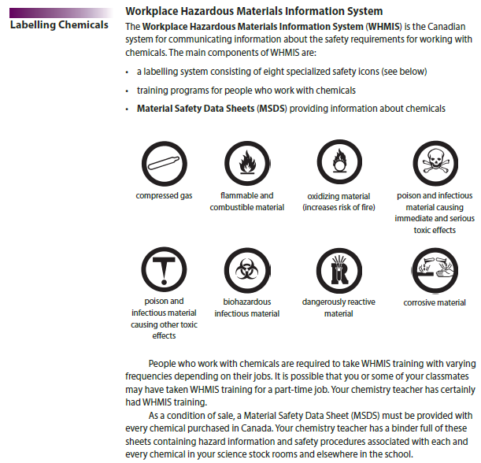
Household Hazardous Products Labels
The Consumer Chemicals and Containers Regulations (CCCR) require specific packaging and labeling of household products. There are only four different household labels.

These labels may be bordered in two different ways. The border indicates whether the label refers to the container or the contents within the container. The octagonal border refers to the contents of the labelled container while the triangular border refers to the container itself.

The latest household labels are as follows:0

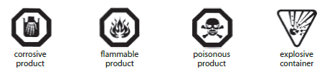
Quick Check
An excerpt from an MSDS for hydrochloric acid solution follows the questions below. This is only an excerpt. An actual M0S0DS may contain more than 15 sections, each of which may be quite detailed. Read this abbreviated excerpt carefully and answer these questions.
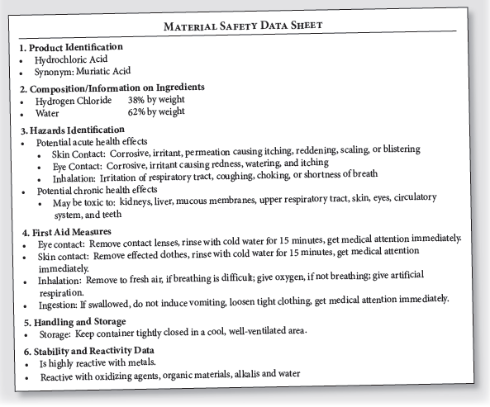

1. What WHMIS labels would you expect to find on hydrochloric acid?
___________________________________________________________
2. Give a synonym for hydrochloric acid.
___________________________________________________________
3. What are the chemicals that make up hydrochloric acid?
___________________________________________________________
4. What are the hazards of spilling hydrochloric acid on the skin?
___________________________________________________________
5. How should you treat a person who has ingested hydrochloric acid?
___________________________________________________________
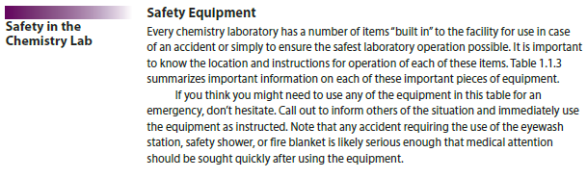
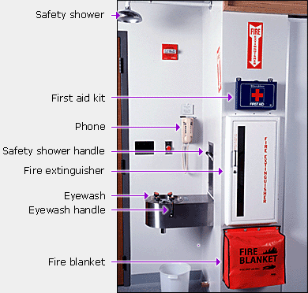

Can you find this important safety equipment in YOUR classroom?

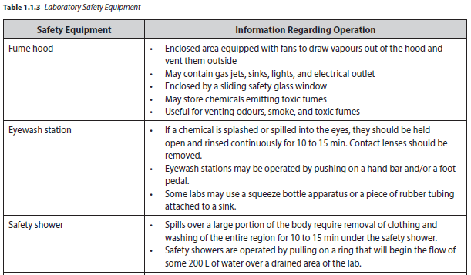
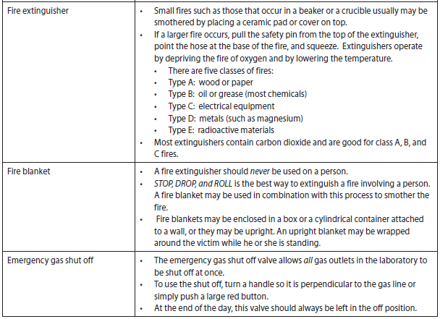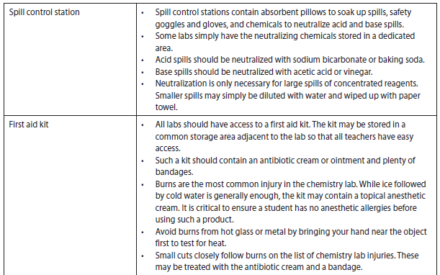
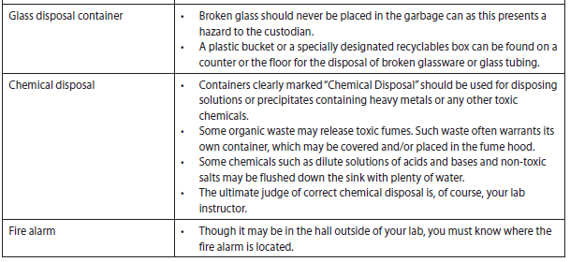
Quick Check
1. How would you deal with each of the following accidents should it occur during a lab you are performing
this year?
- While heating a small amount of alcohol in a beaker, it bursts into flame.

- Your partner hands you a piece of hot glass they’ve just bent after heating over a Bunsen burner.

- A test tube full of concentrated hydrochloric acid is dropped and broken on the floor.

2. How could you have prevented each accident from happening to begin with?
Safety Procedures
Any time you know you will be working in the laboratory, it is important to arrive fully prepared to perform all work as safely as possible. We call this lab preparedness.

The following are some things you should always do before you begin doing a lab.
- Read the entire experiment carefully, paying close attention to any safety issues.
- Prepare any data tables that may be required. Your teacher may ask you to prepare an abstract (summary) or a flow chart before you arrive for lab.
- Clear all binders, backpacks, book bags, coats, etc. away from your work area.
- Always wear eye protection during the laboratory period.
- Wear lab aprons or lab coats if available.
- Tie back long hair to keep it away from flames or chemicals.
- Secure loose sleeves or jewellery to keep them away from flames or chemicals.
- Consider wearing clothing made of natural fibres such as cotton and wool, as those are the most fire resistant fibres.
- Do not wear open-toed shoes during laboratory work.
- Be sure all equipment is in good working order. Do not use chipped glassware or damaged electrical equipment.
- Never attempt laboratory procedures without your instructor’s permission and direct instruction.

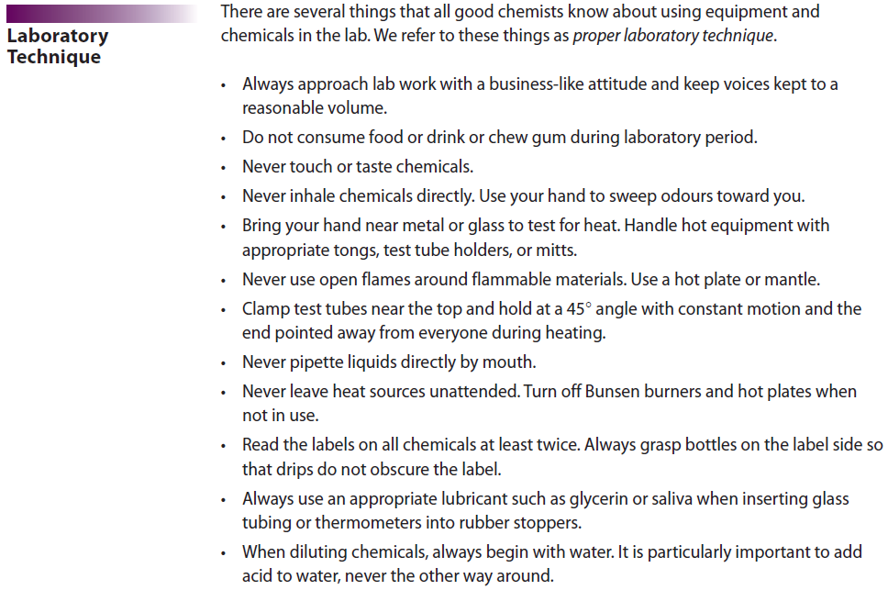

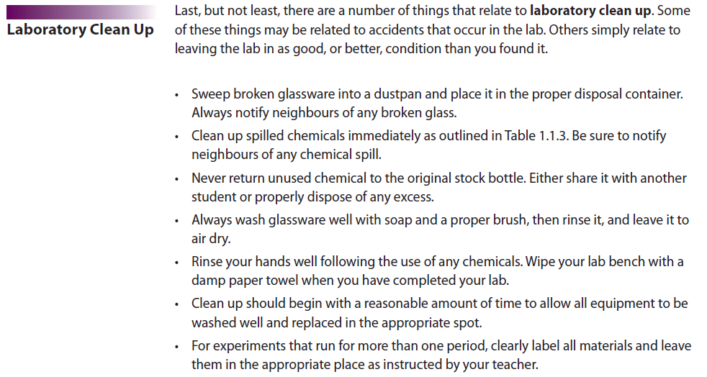
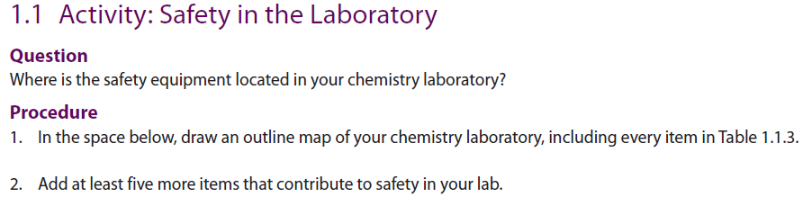

Review Questions
