Chemistry 12

Unit I - Kinetics

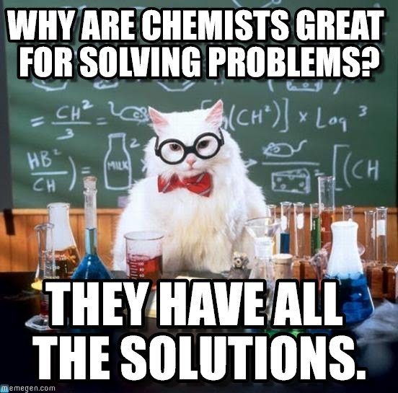
Chemistry 11 Review

I) Mass to Moles
If you have 16.7g of NaOH, convert it to moles NaOH.
Molar Mass of NaOH =

How do you convert mass to moles?

II) Moles to Mass
If you have 0.756 moles of HCN, what mass of HCN is present?
Molar Mass of HCN =

How do you convert moles to mass?

III) Stoichiometry:
2Li_{(s)} + CuSO_{4(aq)} ⇒ Li₂SO_{4(aq)} + Cu_{(s)}
What mass of Cu metal is produced if 14.5g of Li metal reacts?
What should you do first?
When can you transfer from one substance to the other?

Draw the mole map for stoichiometry:

Practice 1: Stoichiometry Exercises
1. Na₂SO_{4(aq)} + BaCl_{2(aq)} ⇒ 2NaCl_{(aq)} + BaSO_{4(s)}
a) How many grams of NaCl would be produced from 80.0g of
BaCl₂ ?
b) How many grams of BaCl₂ would be required to produce 65.5g of NaCl?
2. When iron reacts with copper II chloride, solid copper and iron III chloride are formed. What mass of copper is produced if 0.594 moles of Fe react?

IV) Molarity
Molarity (M) = ___________________ = _____________

Triangle form: What is molarity a measure of?

What do square brackets mean: i.e. [NO₃⁻]

Practice 2: Molarity Exercises
1. What is the molarity of a solution made by dissolving 2.45mol of potassium nitrate in 1.50L of solution?
2. How many moles of NaCl must be dissolved in 400.0mL of solution in order to make a 0.25M solution?
3. What is the volume if 0.555mol of MgS makes a 2.00M solution?
4. Find [NaOH] when 0.32mol NaOH is dissolved in 5.00 x 10² mL of solution?

Kinetics – Unit 1
I) Collision Theory
In a chemical reaction, what actually occurs at the particle level in order for reactants to make products?

This process is called ‘collision theory’.

Particles are always moving as they always have kinetic energy (KE). Solids only vibrate as they have a low amount of KE. Liquid molecules have a medium amount of KE and slide past one another. Gases have a large amount of KE and move around very quickly. Because of all this movement, molecules are always colliding with one another.

Two things can happen as the result of a collision:
1) The reactant particles collide but either don’t have _______________
or don’t have _____________________________ to cause reactant bonds to break. Therefore, they bounce off one another and no reaction occurs.
2) The reactant molecules collide with the correct geometry and with sufficient kinetic energy to cause reactant bonds to break and product bonds to form. This is called an ______________________________________.

When a collision has enough kinetic energy to cause reactant bonds to break, it is said to have reached the threshold energy.

Though it varies for each different reaction, a general rule in chemistry is that only a small percentage of collisions are effective (make products). Why do you think this is the case? Think of the blindfolded walkers’ analogy to help.

What could you say about a reaction that has many effective collisions per second?

What could you say about a reaction that has few effective collisions per second?

What could you say about a reaction that has no effective collisions per second?
The speed of the reaction, otherwise stated as the reaction rate, depends on the amount of effective collisions per unit time. Effective collisions are what produce product particles.

II) Investigating Rate
Reaction Rate:

Mathematically, rate = Δ quantity What is Δ ?
Δ ______
What are some examples of a ‘quantity’ that can change in a reaction?

Therefore, what are some valid units for rate?

Suppose we observe the following reaction in the lab. What are some quantities we could measure over a period of time in order to obtain a reaction rate? Mg_{(s)} + 2HCl_{(aq)} ⇒ MgCl_{2(aq)} + H_{2(g)}

Rate can be measured by measuring the consumption of a reactant, or measuring the production of a product, all the while timing the reaction.
Suppose the rate for the reaction under discussion was determined by measuring the mass loss of the reactant Mg_{(s)} per unit time. Draw a graph to represent this:

Why does the graph have this shape?

Mass
of Mg
(g)

time (s)

Suppose the rate is determined by monitoring the increase in volume of the product H₂ gas. Draw a graph for this:

Why does the graph have this shape?
Vol H₂ gas
(mL)

Time (s)

Remember from math that slope = --------------

What is the rise (y axis) in each of the graphs we’ve just drawn?
A change in ________________________.
What is the run (the x axis) in each?
A change in ________________________.
Therefore, what does the slope of these graphs represent?
_________________ = ___________________ =

What are the units of rate for each of the previous two graphs?

First graph:

Second graph:

Look at the two graphs again. What do you notice about the magnitude of the slope as your reaction proceeds? What does this tell you about reaction rate as a reaction proceeds?

Draw a graph of rate (y axis) vs. time for a reaction:

As reactants get used up, there are
less and less collisions between reactant
particles, therefore less and less effective
rate collisions, so reaction rate is always
decreasing!

time
AS A REACTION PROCEEDS, THE RATE IS ALWAYS DECREASING.

Assignment 1:
1) For the reaction: NaHCO_{3(s)} + HCl_{(aq)} - NaCl_{(aq)} + H₂O_{(l)} + CO_{2(g)}
Describe three things that you could measure while timing the reaction to calculate a reaction rate. For each, state the quantity being measured and what substance is being measured.
2) For the reaction: 2H_{2(g)} + O_{2(g)} 2H₂O_{(l)}
Describe three things that you could measure while timing the reaction to
calculate a reaction rate. For each, state the quantity being measured and what substance is being measured.
3) Hebden page 10, question 17
4) For the reaction: 2H_{2(g)} + O_{2(g)} 2H₂O_{(l)}
Draw a graph for:
a) Mass loss of O₂ per unit time as the reaction proceeds
b) volume gain of H₂O per unit time
c) rate per unit time

III) Calculating Rate
What is the rate equation triangle?

Calculate the rate of the demonstration reaction using the eudiometer tube setup. Mg_{(s)} + 2HCl_{(aq)} ⇒ MgCl_{2(aq)} + H_{2(g)}

Volume of H₂ gas:

Time:

Average Rate:

Why is the rate we calculated an ‘average’ rate?

Calculate the mass of the piece of magnesium used:

We will work through questions #1, 2, and 4 on p.2 of Hebden and then #19 on p.11.

Assignment 2: Rate Calculations
Time (s) | Mass of Pb (g)
0 | 65
15 | 52
30 | 41
45 | 32
60 | 25
1)

The above is data for a reaction in which Pb is a reactant.
a) Calculate the overall rate of the reaction.
b) Calculate the rate from 0-30s and from 30-60s.
c) Explain why the 30-60s rate is lower than the 0-30s rate.
2) When CaCO₃ reacts with HCl, CO_{2(g)} is produced. If 243mL of CO₂
is produced in 22s, what is the rate of the reaction?
3) A 5.0g sample of Mg reacts completely with HCl in 120s. What is the average rate of this reaction in g Mg per minute?

4) How long will it take (in seconds) for 45.0g of Mg to react with HCl, if the average rate of the reaction is 2.30g Mg/min?
5) Electrolysis of H₂O produces O₂ and H₂. If O₂ gas is produced at an average rate of 28.5mL/min, calculate the consumption of H₂O in grams per second.
6) Given the reaction: H_{2(g)} + Cl_{2(g)} ⇒ 2HCl_{(g)}
a) If 2.32g of HCl are produced in 4.0 min, what is the rate of reaction in mol HCl/second?
b) If H₂ is used up at a rate of 30.0 mol/s, at what rate is HCl produced in g/min? (hint: use stoich table!)
7) C₅H_{12(g)} + 8O_{2(g)} ⇒ 5CO_{2(g)} + 6H₂O_{(g)}
If 17.6g of C₅H₁₂ is burned in three seconds, calculate the rate of the reaction in grams of CO₂ per second.

IV) Factors Affecting Reaction Rates
Think back to when we reacted a metal strip of magnesium with 2.0M HCl. What alterations could we make to increase the rate of the reaction?
Mg_{(s)} + 2HCl_{(aq)} ⇒ MgCl_{2(aq)} + H_{2(g)}

1. The ‘nature’ of reactants influences reaction rate:
- Some substances are simply more reactive than others; usually because their bonds will break at lower energy and/or it is easy to obtain correct collision geometry
- the number of effective collisions, and therefore the reaction rate, depend on the reactivity (the nature) of the reactants
- for example, magnesium is a more reactive metal than zinc

2. Concentration influences reaction rate:
- the greater the concentration of an aqueous or gaseous reactant, the more reactant particles per unit space, the more collisions there are between reactant particles, therefore the more effective collisions there will be, and hence an increased reaction rate
- for solutions, concentration refers to ____________________.
- for gases, concentration refers to ____________________.

3. When reactants are heterogeneous, surface area influences reaction rate:
- heterogeneous reactions have reactants that are in different phases, meaning there is an interface between reactants
- if you can expand the size of the interface (increase the _____________), then there are more particles available to ______________ , resulting in more ______________________________________, therefore ________________________________________, therefore an _____________________________________________.
- a homogeneous reaction is one in which there is only ______________________, meaning the reactants are already as mixed as can be, meaning __________________________ has been maximized.
- for example, solutions are homogeneous mixtures that display maximum surface area (already mixed as much as possible – down to the particle)
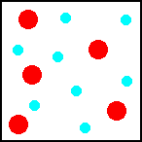

4. Phase of reactants influences reaction rate:
- reactions involving aqueous reactants are instantaneous and are the fastest reactions. What are the possible reasons that this is the case?
1)

2)

So, in general, aqueous state reactants give the highest reaction rates, followed by _____________, because of ________________________,
then ___________________, and the slowest are generally _____________ due to ___________________ and __________________________.

5. Catalysts and Inhibitors influence reaction rate:
- catalysts increase reaction rate, not by producing more collisions, but by increasing the probability of an effective collision. Catalysts remain unchanged at the end of a reaction.
- inhibitors ______________ reaction rate by inhibiting correct geometry and may or may not remain unchanged upon completion of the reaction. Where are inhibitors useful?

6. Temperature influences reaction rate:
- an increase in temperature _________________ reaction rate
- suppose a reaction between two reactants has 100 collisions per second, and 10 are effective. What is the % of effective collisions? __________
- if temperature is increased, the particles move faster, so there will be more collisions per second. Also, the collisions are harder due to the particles moving faster, so there will be a higher % of effective collisions.
- thus, by increasing temperature, maybe there will now be 150 collisions per second, and now maybe 30 are effective. What is the new % of effective collisions? _______

An increase in temperature increases reaction rate due to two factors. Explain each:
1)

2)

- a general rule for temperature change is that every 10 degree increase causes the reaction rate to double

Threshold Energy:
Remember, the threshold energy (TE) is the _________________ amount of KE needed to cause ___________________________________________.

What types of bonds would have smaller threshold energies?

What types of bonds would have larger TE?

An increase in concentration of a reactant causes an increase in reaction rate. Does an increase in concentration decrease the TE (cause the reactant bond energy to change)?

Does an increase in surface are decrease the TE?

Does an increase in temperature decrease the TE?

Factors that can change the TE:
‘Nature’ of reactants is an actual change in reactant, so the bond energy of the reactants will be different, changing the TE.

Adding a catalyst will lower the TE as well, as a catalyst helps particles collide and bonds to break at a lower energy than usual, either due to a reactant collision with the catalyst, or excellent collision geometry.

Assignment 3: Factors Affecting Rate Exercises
Note: When you are asked to explain something using ‘collision theory’ you must comment on how overall collisions, effective collisions, and reaction rate are affected.
1. When a 1.0g cube of Zn reacts with 1.0M HCl, the reaction rate is slower than when a 1.0g cube of Mg reacts with 1.0M HCl. What would be the reason for this?
2. If 1.0g pieces of copper are placed into beakers of 0.50M, 1.0M, and 1.5M nitric acid, explain using collision theory which reaction will proceed at the highest rate and why.
3. If 1.0g pieces of copper are placed into beakers of 0.50M and 1.0M nitric acid, and 1.0g of powdered copper samples are placed into beakers of 0.50M and 1.0M nitric acid, which reaction will be fastest, and why? Which will be slowest, and why?
4. Rank each reaction from fastest (1) to slowest (4).
a) 2NH_{3(l)} + 3F_{2(g)} ⇒ 2NF_{3(l)} + 3H_{2(g)}
b) 2Ag⁺_{(aq)} + SO₄²⁻_{(aq)} ⇒ Ag₂SO_{4(s)}
c) Fe_{(s)} + H₂S_{(l)} ⇒ FeS_{(s)} + H_{2(g)}
d) HNO_{3(aq)} + H₂O_{(l)} ⇒ NO₃⁻_{(aq)} + H₃O⁺_{(l)}
5. Hebden p.8 #13
6. If the rate of a slow reaction at 20°C is 0.040 mol/s, what is the rate at (a) 40°C? (b) 10°C?
7. Suppose a reactant has a triple bond. How will its threshold energy compare with a reactant that has a single bond? How will this affect reaction rate?
8. Hebden p.12 #21

V) Energy Changes in Reactions
What two things are necessary for a collision to be effective (for a reaction to occur)?

But how does the KE actually contribute to breaking reactant bonds?
As reactant particles approach, their KE (speed) begins to ________________ due to ______________________________ between the two reacting particles. Since energy cannot be destroyed, the KE is _____________________ to __________________ energy (potential energy - PE), which is stored mainly in the bonds.
At particle impact, the KE is at its ____________ and the PE at its _______________. If enough PE built up in the reactant bonds, they will break and the product bonds form, resulting in an effective collision and creation of products.

What happens if not enough PE is built up to break reactant bonds?

Whether products form or not, when particles move away from one another after impact, the KE _______________, therefore the PE ____________________.
As KE ⇑, PE & as KE ⇓, PE (KE and PE are inversely related)

If the collision is effective, there is a moment in time when reactant bonds are breaking, and simultaneously ___________________________. This structure is called the ___________________________, as shown in the middle diagram below:
H--H ⇒ H-- H ⇒ H H
+ | | | + |
Cl--Cl Cl-- Cl Cl Cl
Reactants Activated Complex Products
-reactant bonds breaking
and simultaneously product
bonds forming

Activated complexes are very short lived, and very unstable. It is the point in the collision when PE is _______________________________.
When discussing reaction energy from a KE standpoint, the threshold energy is the minimum amount of KE needed to cause the reactant bonds to break. But since the KE must transfer to PE first, the activation energy (Ea) is the minimum amount of PE needed to cause reactant bonds to break.
So, Threshold Energy (KE) = Activation Energy (PE)
Define activation energy:

As a collision is occurring, sketch how PE changes:

PE

Progress of Reaction

VI) Change in Enthalpy: ΔH
Every reaction involves either an absorption, or a release, of energy, usually in the form of heat. Enthalpy is potential energy that may be evolved (released) or absorbed as heat.
What is an exothermic reaction?

What is an endothermic reaction?

The following reaction is exothermic. Write an ‘energy’ term on the appropriate side:
2C₂H₂ + 5O₂ 2H₂O + 4CO₂

Therefore, where is the ‘energy’ term written for an endothermic reaction?

Draw a PE curve for an exothermic reaction on graph (a), and an endothermic reaction on graph (b):
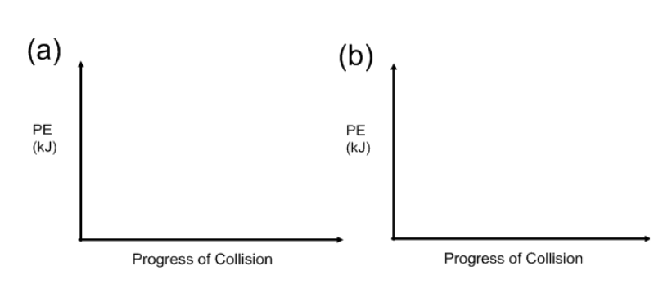

Enthalpy (analogous to energy) can be abbreviated as H, and is measured in Joules (J) or kilojoules (kJ). The change in enthalpy, ΔH, for a reaction, is always calculated as:

ΔH = H_{products} - H_{reactants}
So looking at the previous two graphs, what characteristic would ΔH have for exothermic reactions?

For endothermic reactions?

In summary, there are three ways to identify if a reaction is exothermic or endothermic:. What are they?

If exothermic:
1)

2)

3)

Draw an endothermic PE curve and label the reactants, products, activation energy, activated complex, and ΔH. State whether the ΔH is positive or negative.

PE
(kJ)

Progress of Reaction

What implications would a large E_{a} have on reaction rate?

What about a small Ea?

Draw 4 PE curves below. The first should represent a reaction that is spontaneous and exothermic. The second – non-spontaneous and exothermic. The third – spontaneous and endothermic. The fourth – non-spontaneous and endothermic.
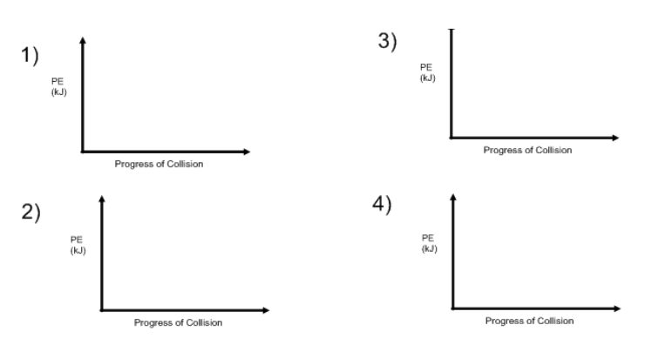

Assignment 4: PE Curve Exercises
Tip: When drawing PE curves, never put the reactants or product energies at zero. Particles always have some potential energy.
1. Hebden p.25 #41-45
2. Draw a PE curve with labeled axes that has reactant energy of 100kJ, an Ea of 200kJ and a ΔH of 150kJ. On the y axis, make a scale from 0kJ to 400kJ, with increments every 50kJ.
A) Is this reaction exothermic or endothermic?
B) Are the products more stable than reactants?
C) What is the PE of the activated complex?
3. Sketch a PE diagram for a reaction that has an E_{a} = 20kJ, a ΔH = -30kJ, and a product energy of 10kJ.
4. Does reaction rate depend on activation energy? Why or why not?
5. Does reaction rate depend on ΔH? Why or why not?

6. Read p. 24 & 25 in Hebden, then answer the questions below using the following PE curve:

400

300
PE
200

100

0
Progress of Reaction
a) Find the Ea of the forward reaction.
b) Find the Ea of the reverse reaction.
c) Find ΔH for the fwd reaction. Endo or exo?
d) Find ΔH for the reverse reaction. Endo or exo?
e) What would happen to the activation energy if the temperature is increased?

7. Explain in terms of energy changes (kinetic and potential) what occurs when two molecules approach each other, collide, and move away as products. Be very specific and use correct vocabulary.

8. Which of the following is endothermic?
a) 2H_{2(g)} + O_{2(g)} - 25kJ ⇒ 2H₂O_{(l)} b) 2H_{2(g)} + O_{2(g)} ⇒ 2H₂O_{(l)} + 25kJ

c) 2H_{2(g)} + O_{2(g)} + 25kJ ⇒ 2H₂O_{(l)} d) 2H_{2(g)} + O_{2(g)} ⇒ 2H₂O_{(l)} ΔH = -25kJ

9. Draw a picture of an activated complex for the following reaction:

H_{2(g)} + Br_{2(g)} ⇒ 2HBr_{(g)} ΔH = -125kJ

VII) Catalysts and Inhibitors
Every type of reaction follows a specific and consistent pathway with a unique activated complex. When a catalyst is introduced to the reaction, the pathway changes and a different activated complex is formed with a lower Ea. Because of this lower Ea, a higher % of collisions are effective, thereby increasing the reaction rate.

catalyzed reaction has lower Ea

PE

Progress of Reaction
Catalysts are involved in creating a different, lower energy activated complex, but remain unaltered at the end of the reaction.
An inhibitor forms a new activated complex that has a larger activation energy, thereby decreasing reaction rate.
Catalysts lower the Ea, thereby increasing the rate, but do they alter ΔH for the reaction? (look at the curve on above)

A catalyst is written above the reaction arrow in a reaction. However, sometimes, it’s written as a reactant and a product (as it does not get used up in a reaction).
Example
Uncatalyzed (very slow):
2H₂O_{2(aq)} ⇒ 2H₂O_{(l)} + O_{2(g)} + energy

Catalyzed (fast)
MnO_{2(s)}
2H₂O_{2(aq)} ⇒ 2H₂O_{(l)} + O_{2(g)} + energy OR:
2H₂O_{2(aq)} + MnO_{2(s)} ⇒ 2H₂O_{(l)} + O_{2(g)} + MnO_{2(s)} + energy
Draw a PE diagram for the uncatalyzed and catalyzed decomposition of H₂O₂ (hydrogen peroxide).

PE

Progress of Reaction

A heterogeneous catalyst is in a different phase than reactants, and usually adsorbs the reactant (holds it on its surface) to allow better geometry with other reactants.

A homogeneous catalyst is in the same phase as reactants, and usually alters the regular reaction pathway to a new, lower energy reaction pathway.

IX) Specific Examples of Catalysts
Automobile Catalytic Converters
- Vehicles produce NO (nitric oxide) as a result of the synthesis reaction of N₂ and O₂ from air in the high temperature engine where fuel combusts.
Some NO then oxidizes to produce NO₂ (nitrogen dioxide) which can form nitric acid (HNO₃) when it reacts with water vapour in the atmosphere. CO (carbon monoxide) is also released in exhaust, a poisonous gas.
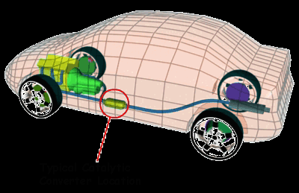

In 1981, automobiles were equipped with a catalytic converter in the exhaust system, which consists of two chambers:
Chamber 1 - contains platinum and palladium catalysts that help convert CO to less harmful CO₂ .
Chamber 2: contains platinum and rhodium catalysts which help convert NO back to unharmful N₂ and O₂.

Autocatalysis
Autocatalysis occurs when the product of a reaction serves as a catalyst for the same reaction, creating a chain reaction. The reaction starts slowly but picks up speed once the catalyst begins to form.
Ex. reaction of the permanganate ion (MnO₄⁻) by the oxalate ion (C₂O₄²⁻) in acid with Mn²⁺ autocatalysis:
2 MnO₄⁻ + 5 C₂O₄²⁻ + 16 H⁺ 2 Mn²⁺ + 10 CO₂ + 8 H₂O
*products form faster if Mn²⁺ is provided at the beginning of the rxn.

Hydrogen Peroxide Decomposition:
2 H₂O₂ 2 H₂O + O₂
H₂O₂ is a harmful product formed mainly due to the breakdown of fatty acids in the liver of animals and via photorespiration of glucose in plants.
H₂O₂ kills cells non-specifically by disrupting cell membranes, thus it is used as a wound cleaner to kill bacteria. Within organisms, excess H₂O₂ can be harmful.
Two known catalysts to decompose hydrogen peroxide into water and oxygen:
1. Manganese (IV) oxide (MnO₂) – used in the lab
2. The enzyme (biological catalyst) catalase, found in the liver of animals. Used to decompose excess H₂O₂ in the body.
3. Catalase is also present in plants such as potatoes.

Assignment 5: Catalyst Exercises

500

400

300
PE 250

200

100

0

Progress of Reaction
1. Label and calculate the activation energy for the:
a) uncatalyzed forward reaction. b) catalyzed forward reaction
c) uncatalyzed reverse reaction d) catalyzed reverse reaction
2. Calculate the potential energy of the:
a) uncatalyzed activated complex
b) catalyzed activated complex
3. Calculate the difference in activation energy for the uncatalyzed reaction and the catalyzed reaction.
4. Find the ΔH for the:
a) uncatalyzed forward reaction
b) catalyzed forward reaction
c) What do you notice about the two?
5. Can a catalyst cause an endothermic reaction to become exothermic? Why or why not?
6. A catalyst increases reaction rate in a different way than increasing temperature. Explain how each are different using collision theory.

PE Curve – Reversible Reactions Summary:
- ΔH for the forward and reverse reactions have the same magnitude but opposite signs
- E_{a} is always smaller for the endothermic reaction
- altering temperature, pressure, concentration, or surface area will have no effect on a potential energy diagram. Only the addition of a catalyst or inhibitor can do this by altering the E_{a}

VIII) Reaction Mechanisms
Reactions are expressed using a reaction equation. The equation gives information about the reactants and products, but very little information about the process that occurs to get from reactants to products. An equation suggests a one step process, which is in reality seldom the case. Most reactions involve a series of steps, called a reaction mechanism.
Example: 4HBr + O₂ ⇒ 2H₂O + 2Br₂
The chemical reaction above actually has a three step mechanism. Why doesn’t this reaction occur in one step (think about the collisions that would have to occur)?

The three step mechanism for HBr reacting with O₂:
Step 1: HBr + O₂ ⇒ HOOBr + energy rate: fast
Step 2: HOOBr + HBr + energy ⇒ 2HOBr rate: fast
Step 3: 2HOBr + 2HBr ⇒ 2H₂O + 2Br₂ + energy rate: slow

Overall: ΔH = negative

a) Which step is the rate-determining step and why?
b) Why are HOOBr and HOBr not part of the overall reaction equation?
c) Draw a potential energy curve for the 3 step mechanism.

PE

Progress of Reaction
HOOBr and HOBr are called _______________________________________.

Define Reaction Intermediate:

Notice that reaction intermediates are not part of the overall reaction because they "cancel out".
The first place you will see a reaction intermediate is on the ______________ side and then subsequently on the _________________ side.

Example:
Step 1: O₃ + NO + energy ⇒ NO₂ + O₂ rate: fast
Step 2: NO₂ + O ⇒ NO + O₂ + energy rate: slow

a) What is the overall reaction?

b) State any reaction intermediates.

c) Which is the rate determining step?

d) Sketch a PE curve for the mechanism. The overall reaction is endothermic.

PE

Progress of Reaction

What was the role of NO in the last example?

Catalyst: a substance that ________________ the rate without being consumed in a reaction
The involvement of NO created a different, lower energy mechanism for the reaction.
What happened with NO in step 1?

What happened with NO in step 2?

Why must catalyzed reactions involve a two-step mechanism?

A catalyst is usually not part of the overall reaction (not a reactant or product) because it "cancels out".
You’ll see a catalyst on the _______________ side first, and then on the ________________ side.

Example:
Step 1: Br₂ + H₂O₂ ⇒ 2Br⁻ + 2H⁺ + O₂
Step 2:
Overall: 2H₂O₂ ⇒ 2H₂O + O₂
a) Determine step 2.

b) Identify any reaction intermediates.

c) Identify any catalysts.

Assignment 6: Reaction Mechanism Exercises

1) Step 1: 2NO + H₂ ⇒ N₂ + H₂O₂ rate: slow
Step 2: H₂O₂ + H₂ ⇒ 2H₂O rate: fast
a) What is the overall reaction?
b) Which is the rate determining step?
c) Identify any reaction intermediates.
2) Step 1: rate: fast
Step 2: N₂O₂ + Br₂ ⇒ 2NOBr rate: slow
Overall: 2NO + Br₂ ⇒ 2NOBr
a) Find Step 1.
b) If it was possible to increase the rate of step 1, how would this affect the overall reaction rate?
c) Identify any reaction intermediates.

3) Why does the following reaction have a multi-step mechanism?
3FeCl₂ + KNO₃ + 4HCl ⇒ 3FeCl₃ + NO + 2H₂O + KCl

4)

PE

Progress of Reaction

a) How many steps make up the reaction mechanism?
b) State whether each step is endothermic or exothermic.
c) Is the overall reaction endothermic or exothermic?
d) Which is the rate determining step? How can you tell?
e) Label ΔH for the overall reaction on the curve.
f) On the curve, label an A wherever there is an activated complex and an I wherever there is a reaction intermediate. How do the two differ?
5) Consider the following mechanism:
Step 1: NO₂ + Mn ⇒ NO₂Mn
Step 2:
Step 3: NO₃ + CO ⇒ NO₂ + CO₂
Overall: NO₂ + CO ⇒ NO + CO₂
a) Determine Step 2.
b) Identify a catalyst.
c) Identify any reaction intermediates.
d) What would be the chemical formula of the activated complex in
Step 3?
6) Step 1: H⁺ + H₂O₂ ⇒ H₃O₂⁺ rate: fast
Step 2: rate: slow
Overall: H⁺ + I⁻ + H₂O₂ ⇒ H₂O + HOI
a) Detemine Step 2.
b) Identify any reaction intermediates.
c) Which is the rate determining step?
d) What is the formula for the activated complex in Step 2?
(don’t forget to sum charges!)
7) Step 1: ClO⁻ + ClO⁻ ⇒ ClO₂⁻ + Cl⁻
Step 2: ClO₂⁻ + ClO⁻ ⇒ ClO₃⁻ + Cl⁻
a) What is the overall reaction?
b) What would the chemical formula be for the activated complex in Step 1? (don’t forget to sum charges!)
c) Identify any reaction intermediates.
8) Step 1: NO + NO ⇒ N₂O₂ exothermic / rate: fast
Step 2: endothermic / rate: slow
Step 3: N₂O₄ ⇒ 2NO₂ exothermic / rate: fast
Overall: 2NO + O₂ ⇒ 2NO₂ exothermic
a) Determine Step 2.
b) Sketch a PE diagram for the reaction mechanism.

