Name: Block:
Group Members: Date: / /2018
Due Date: Drop Date:

Criteria | Student Self Evaluation | Teacher  Assessment
Objective: Clearly states the purpose of the experiment, written in your own words and briefly outlines the related theory.  Procedure: correctly references textbook or handout making notes of any changes. | /2 | /2
Flow Chart: a visual representation of the procedure, to be completed before the lab!  Pre-Lab Questions: displays a critical understanding of the background theory. | /11 | /11
Data, Results & Calculations:  Provides results/observations (and diagrams where appropriate) that are presented in correctly annotated tables and/or graphs. Scientific tables & graphs are numbered (eg Table 1:… or Graph 1…) and include descriptive titles. | /21 | /21
Follow-up Questions:  Correctly identifies and explains the theory relating to the experiment and supports this with accurate observations, data and/or calculations. | /24 | /24
Conclusion:  Identifies and defines important concepts and principles relevant to the experiment by relating back to the objective and hypothesis. Be sure to address the points listed in the lab handout when answering the conclusion. | /2 | /2
Presentation:  Practical report is presented in the correct format, is written fluently and provides appropriate section headings and accurate referencing. Tables & graphs have numbered headings. Data & calculations may be hand written, however the remainder of the report is to be word-processed. | /2 | /2
Practical Evaluation: (teacher assessed during practical lab work)  Arrives to class prepared with pre-lab complete. Demonstrates an organized and safe approach to experimental work & meticulously executed methodology to a high degree of accuracy. | /5 | /5
Results Summary | /67 | /67

We will be doing the lab on __________________________. In order to be ready to go, you need to complete the following sections of your lab report BEFORE arrive to class on the day of the lab:
- Flow Chart
- Pre-Lab Questions
- Data & Observations: Draw & set-up Table 1 into your lab notebook & make predictions
Objective:
- to mix several pairs of solutions together and then note whether any precipitates form
- to deduce, from the experimental results, which combinations of ions form precipitates
- to write a balanced formula equation for each precipitation reaction

Procedure: This lab is an excerpt from Heath Chemistry page 177-179, a textbook of laboratory experiments.

1. Put on your safety goggles
2. Obtain a sample of each solution in each of the 11 samples
3. Place a drop of one solution on the spot plate and, using the appropriate dropper, add a drop of second solution to it. A piece of paper with a grid drawn on it can be placed under the spot plate so that several tests can be done at a time.
4. If a precipitate forms, record this result in the copy of Table 1 in your notebook by placing "ppt" in the appropriate square. If no precipitate forms, simply mark a dash(-) in the square. Be sure to record all observations: speed of reaction, colour and thickness in your table.
5. Repeat Steps 2 and 3 until all possible combinations of solutions have been tested.
6. Follow the reagent disposal instructions, then rinse out all equipment and dry the spot plate.
7. Before you leave the laboratory, wash your hands thoroughly with soap and water.
Safety glasses are to be worn at all times, for all experiments!

Reagent Disposal: All waste from this lab is to be rinsed down the sink with plenty of water to dilute. All glassware used must be rinsed thoroughly in order to be used in future labs.

Clean Up: clean up all materials, wipe lab bench with disinfectant and wash hands well with soap and water before you leave the lab each day.

Flow Chart: Summarize the steps that you will follow in the lab. You will find this information on the attached pages, which give the “procedure” for the lab. These steps should be VERY simple, and easy to follow.

Pre-lab Questions: (to be answered in full sentences)

- Describe what a double replacement reaction involves (1 mark)
- Define the following terms: (3 marks)
  - Cation
  - Anion
  - Ionic compound
- There are three categories of double replacement reactions:
  - List the 3 categories (1 mark)
  - Briefly describe each & provide an example (3 marks)
- Precipitates form when a low solubility salt has been produced in a double replacement reaction. Explain what a precipitate is and describe what is mean by the term low solubility salt. (2 marks)

Data & Observations the following table may be used during the lab, but a good copy is expected to be written/typed for submission of the final report.

Under “predicted” use your data table to predict whether a precipitate will form and write it in the box.(18 marks)

Under “observed” include the following three points: speed of reaction & colour & thickness. (3 marks)

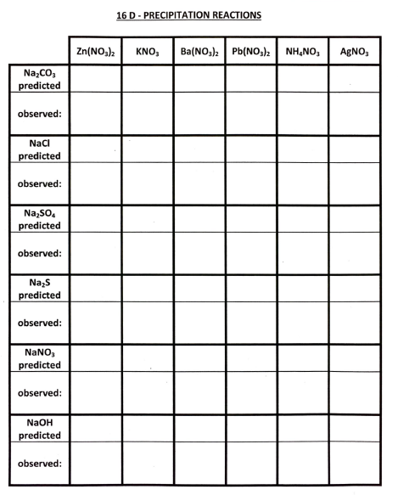

Questions & Calculations (to be answered in full sentences)

- What observations led you to believe that precipitates formed? (1 mark)

- Construct a table summarizing your results similar to Table 2 (shown below) which shows those combinations of ions that formed precipitates and those that did not. (8 marks)
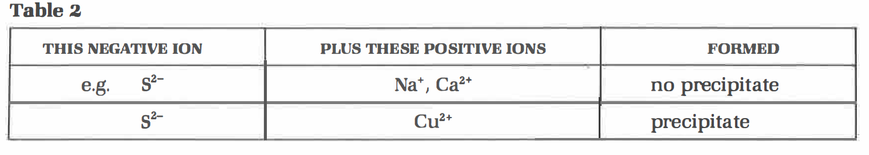

- Write balanced equations, including states, for the reactions between the following solutions:
  - sodium carbonate and calcium nitrate (3 marks)
  - sodium hydroxide and silver nitrate (3 marks)
  - sodium chloride and lead(II) nitrate (3 marks)

- Which negative ion(s) formed no precipitates? (1 mark)

- Which positive ion(s) formed no precipitates? (1 mark)

- Why are nitrate compounds often used when a particular positive ion is needed in solution? (1 mark)

- What positive ion is often present in a compound when a particular negative ion is needed in solution? Why? (1 mark)

- Use a solubility table to identify two soluble substances whose solutions could be mixed to form two precipitates. (2 marks)

Conclusion:
Your conclusion should briefly summarize the experiment and state your experimental results. Be sure to address your objective(s). Discuss any sources of experimental errors and how this may/or may not have impacted your results. It is important to make suggestions to improve the experiment in order to minimize these sources of error for future experimentation (2 marks)

