Chem 11 Matter & Inorganic Naming Review Package _________________________
Hebden: Units III & IV __________________
UNIT III: MATTER
In addition to these questions, make sure to look at the definitions and examples in your notes.
- A mixture (is / is not) composed of two or more substances.
- True or False: An element can be broken down into a simpler substance.
- From the following list, circle the ones that are elements:

silver
water
oxygen
air
carbon dioxide
hydrogen
gold
sulphur
alcohol
carbon
sugar
magnesium
chromium
nitrogen
salt
nickel

- Draw the classification of matter diagram. Be sure to include the following: matter, suspensions, compounds, mixtures, pure substances, elements, solutions, and mechanical mixtures. Write a characteristic below each word. Give examples of the two kinds of pure substances and the three kinds of mixtures.

- Classify the following as pure substances or mixtures.
air __________________
water __________________
mercury __________________
gasoline __________________
sugar __________________
oxygen __________________
gold __________________
salt water _________________

- Classify the following as heterogenous or as homogeneous (assume they are all mixtures).

salt water _________________
aluminum foil ______________
tap water ________________
tossed salad ________________
unfiltered air_______________
an apple ________________
iron with rust ______________
wood ______________

- a) Explain the principles behind how chromatography works.

b) Calculate the R_{f} and identify the dye used from this data.
Table 1. Chromatography Data.

 | Colour | d₁ (cm) | d₂ (cm) | R_{f} | Identified Dye
Unknown #1 | Blue | 6.7 | 8.6
Unknown #2 | Red | 4.9 | 8.2

Table 2. Known Dyes and R_{f} values.
Dye | Red #2 | Red #3 | Red #4 | Yellow #5 | Yellow #6 | Blue #1 | Blue #2
R_{f} | 0.81 | 0.41 | 0.62 | 0.95 | 0.77 | 1.0 | 0.79

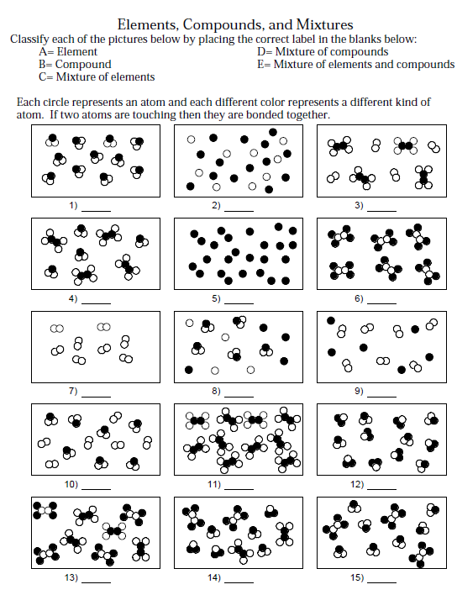
- Answer the questions below.

- Classify the following properties of matter as physical or chemical.

Colour ___________________
Density __________________
Burns easily (flammable) ___________
Boils at 450°C ________________
Melts at 145°C ________________
Dissolves in water ________________
- Classify the following as an intensive property (I) or an extensive property (E).
Mass ____________________
Density ____________________
Melting Point ____________________
Colour _____________________
Volume _____________________
Length _____________________

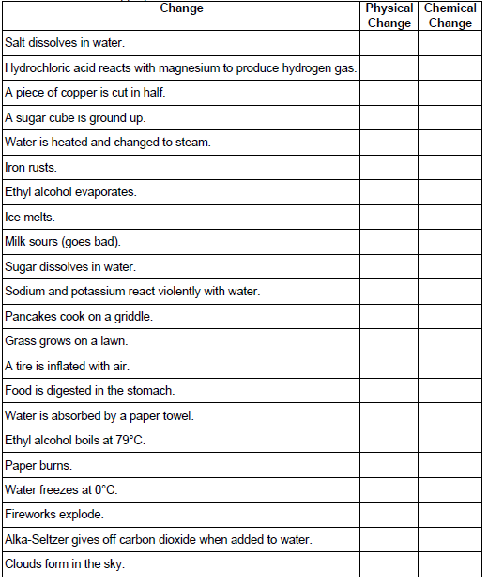
- Fill in the table below by checking the appropriate column.

- Draw a heating curve for both a pure substance and mixture below (on separate graphs). Be sure to include the following:
  - x and y axis titles
  - Label: solid, liquid and gas states
  - Label: phase changes occurring (melting/freezing & evaporation/condensation points or ranges)
  - Be sure that the difference between the curves of two graphs is obvious!

Heating Curve of a Pure Substance

Heating Curve of a Mechanical Mixture

UNIT IV: INORGANIC NOMENCLATURE
In addition to these questions, there are a LOT more question in your textbook under Unit IV.
- Write the word that best characterizes each given species from the choices:
atom anion cation molecule polyatomic ion
a) S^{2–} _________________ b) C₂H₆ _________________
c) Y³⁺ _________________ d) Tl _________________
e) CrO₄^{2–} _________________
- Name the following compounds.

Write out ions with
their charges here
↓
  - NaOH ____________________________________
  - NH₄H₂PO₄ ____________________________________
  - C₃S₅ ____________________________________
  - Fe(CH₃COO)₃ ____________________________________
  - Mn₂O₃•3H₂O ____________________________________
  - Cu₂Cr₂O₇ ____________________________________
  - H₂SO₃(aq) ____________________________________
  - NiSO₃•7H₂O ____________________________________
  - BaCO₃ ____________________________________
  - FeSO₄•5H₂O ____________________________________
  - CH₃COOH ____________________________________
  - I₂O₅ ____________________________________
  - HNO₃ ____________________________________
  - HClO₃ ____________________________________
  - Hg₂C₂O₄ ____________________________________
- Write the formula for each of the following compounds.

- calcium nitride __________________
- methane (aka carbon tetrahydride) __________________
- molybdenum (V) sulfide trihydrate __________________
- nitric acid __________________
- zinc hydrogen sulfite __________________
- iron (II) dihydrogen phosphate __________________
- iron (III) sulfate nonahydrate __________________
- lead (II) iodide __________________
- hydrocyanic acid __________________
- lead (II) acetate decahydrate __________________
- xenon tetrafluoride __________________
- ammonia (aka nitrogen trihydride) __________________
- hypochlorous acid __________________
- mercury (I) monohydrogen phosphate __________________
- manganese (VIII) sulfide tetrahydrate __________________

