FOM & Pre-Calc 10 Trigonometry PRACTICE Test
- On the following triangles, label H for Hypotenuse, O for Opposite and A for adjacent in the boxes below.
a) b) c)
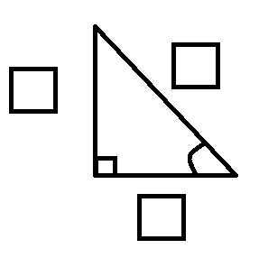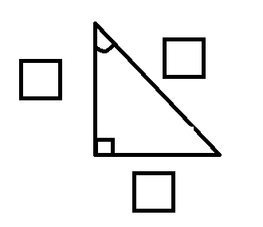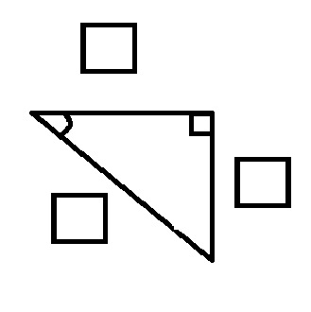

- On each of the triangles below, use the measurements given to write a fraction answer
For each ratio ( $Tan∝, Sin∝and Cos∝$ ). Use the boxes below to write your answers.
(a) (b)
12
10.5
7
$$θ∝$$
23
$$∝$$

9
19.5
$$Tan ∝ =$$
$$Tan θ =$$

$$Sin∝ =$$
$$Sin θ=$$

$$Cos∝ =$$
$$Cos θ =$$

- Use your Calculator to calculate and write down the values of the following correct to 2 decimal places (remember your rounding rules)
a) Tan 35⁰ = | b) Sin 72.5⁰ =
c) Cos 12.4⁰ = | d) Tan 88.45⁰ =

- For each diagram use trigonometry to find the length of the unknown side.
Complete each question showing all working.
a)  x  35⁰  14cm | b)  20⁰  8.5 c | c)  a 45.75m  40⁰

- Use your calculator to find the angle $∝$ if: (answer to 2 decimal places)
(a) $Sin ∝=0.75$ (b) $Tan ∝=1.25$ (c) $Cos ∝=0.85$

- Use trigonometry to find the measure of the angle marked with $∝$ in each diagram.

(a) (b)
32.5 m
$$∝$$
27 m
15 cm

$$∝$$
9 cm

- The slope of a suburban road up a hill is 19º. A map shows that the road covers a horizontal distance of 875m to reach the hill. What is the actual length of the road that has to be covered by bitumen surface to the top of the hill? (Draw a clearly labelled diagram to represent this information).

- An ant is 7.5 metres away from a building that is 20 metres high. Calculate the angle of elevation from the ant to the top of the building correct to one decimal point. (Draw a diagram to display this information)

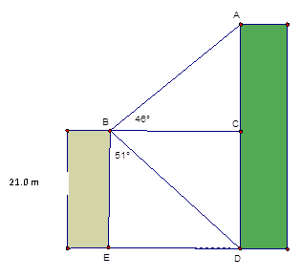
- From the top of a building 21.0 m tall, the angle of
elevation of the top of a taller building is 46°.
The angle of depression of the base of the taller building is 51°.
What is the height of the taller building?

- Find the length of AD. Show the steps of your solution.
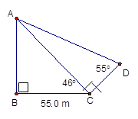

- How would you calculate the length of AB using the information provided? Show all your steps.
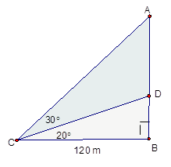
- A Plane takes off and begins a steady climb at an angle of 15$°$ and flies for 2 km.
What is the altitude (height) of the plane in metres? (Be sure to include a labelled diagram).

- You are standing 6m from your house, and 10m from a large tree in your yard. The angle between you and the top of your house is 57.72°. The distance from the top of the tree to your feet is 48.54m.

- Draw a diagram to display this information.

b) Calculate the angle of elevation from the feet of the person to the top of the tree.

- Calculate the height difference between the tree and your house. (show all working out including a diagram)

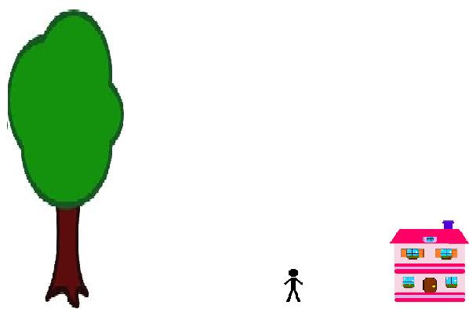

- Johnathon Thurston is setting up to kick a conversion for the Cowboys for a try that was scored in front of the goal posts. When he looks up at the top of the football goalpost, his eyes are 1.7m above the ground and he is looking at an angle of elevation of 35 degrees. He positions himself so that he is standing 20m away from the base of the football goal. Using all of this information and your knowledge of trigonometry, draw a diagram and calculate the height of the goal post. Include a brief sentence explaining your answer.
