Show All Work! Name:________________________
Remember Units!

Math 9 - Unit 3 Practice Test
/48

- Write as a power and then evaluate. (2 marks each)

a) (4)(4)(4)

b) – 6x6x6 =

- Write as a repeated multiplication and then evaluate (2 marks each)

a) 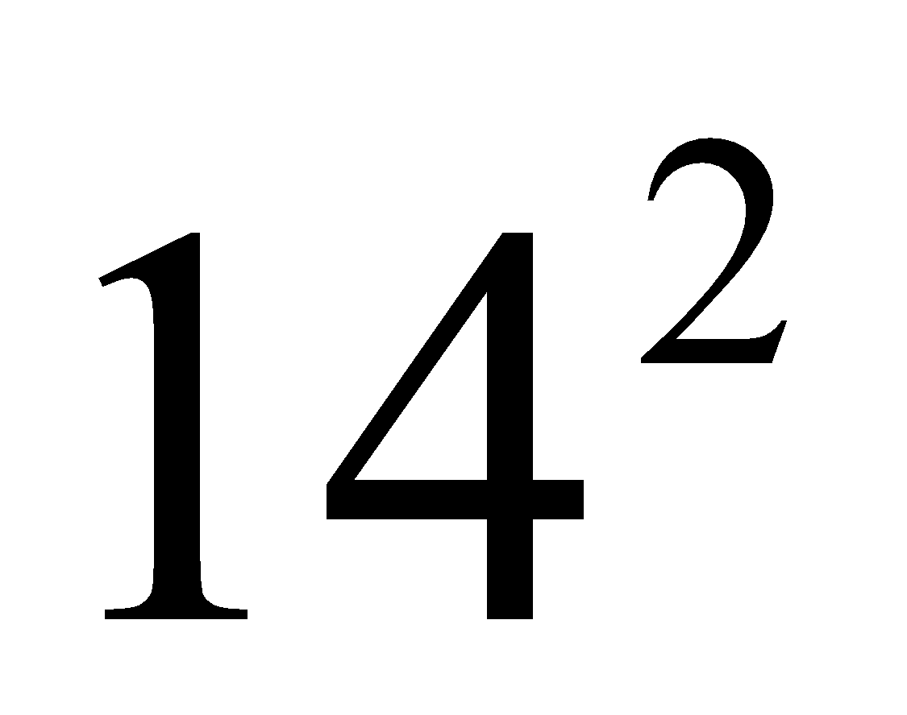=

b) 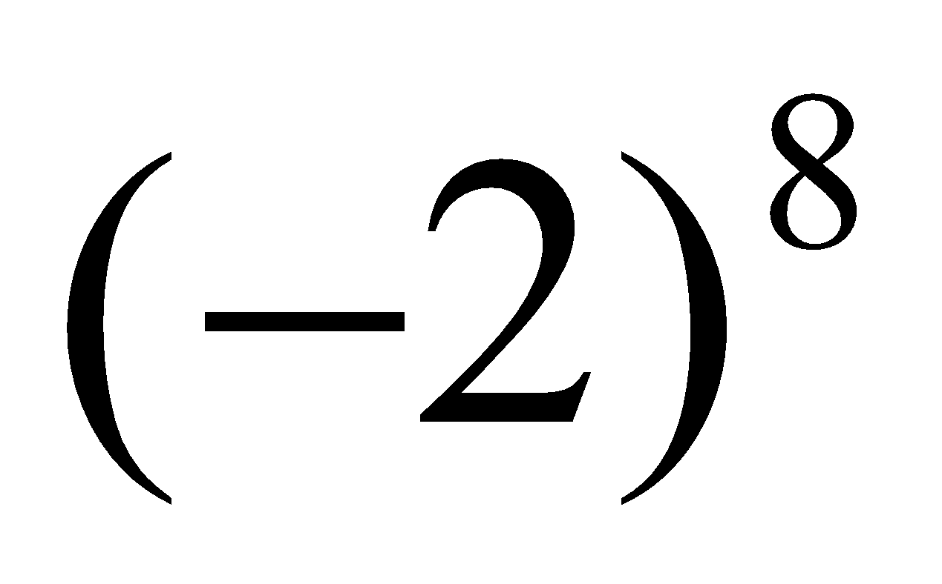=

- Explain how 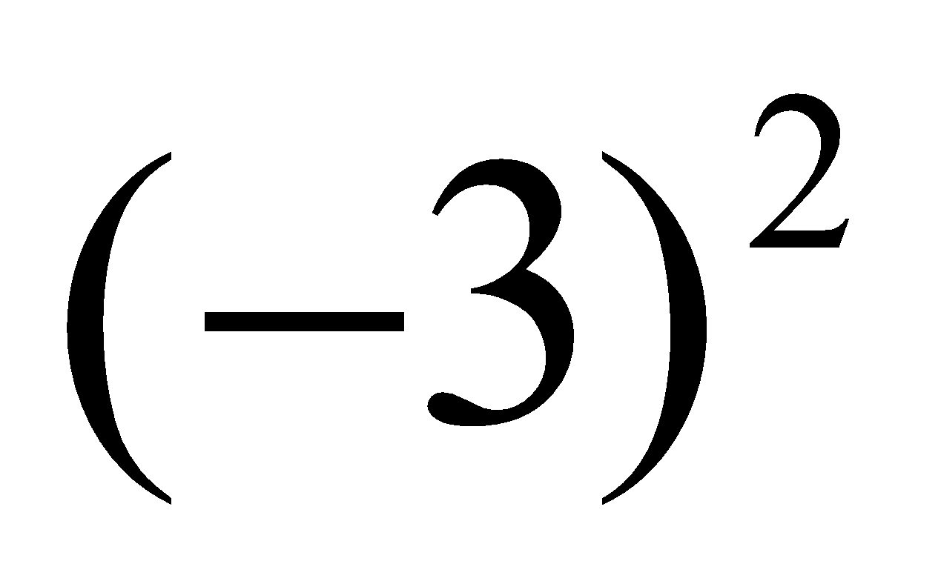 is different from 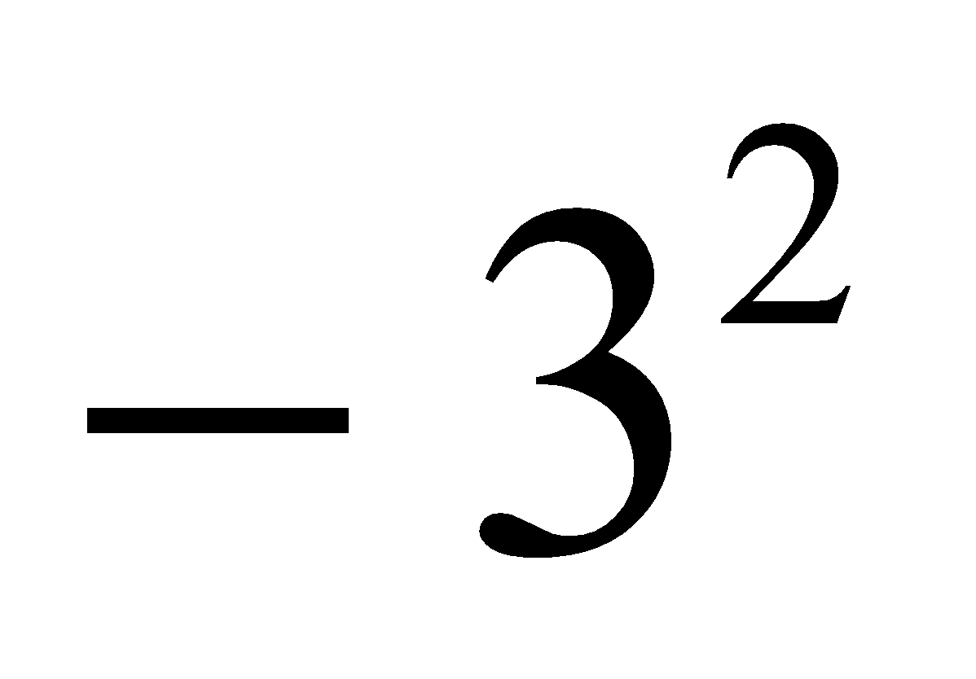. (1 mark)

- Evaluate. (1 mark each)

a) 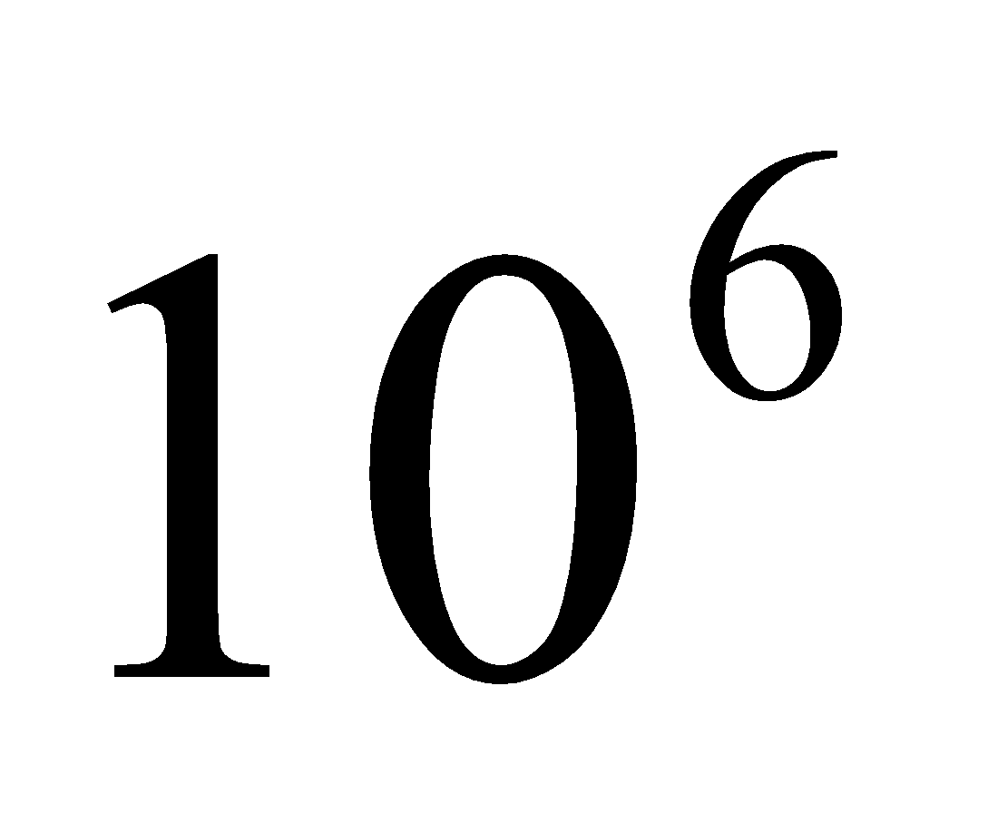 b) 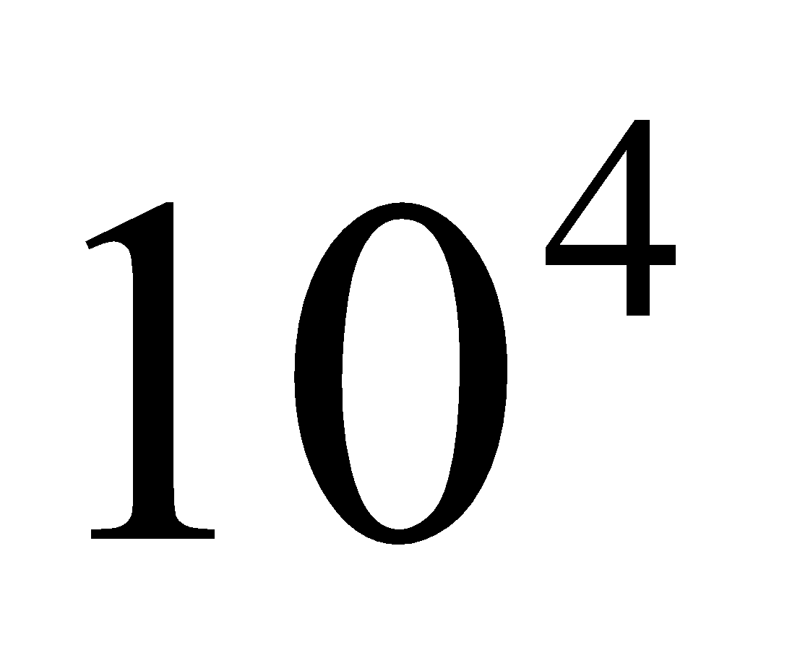

c) d) 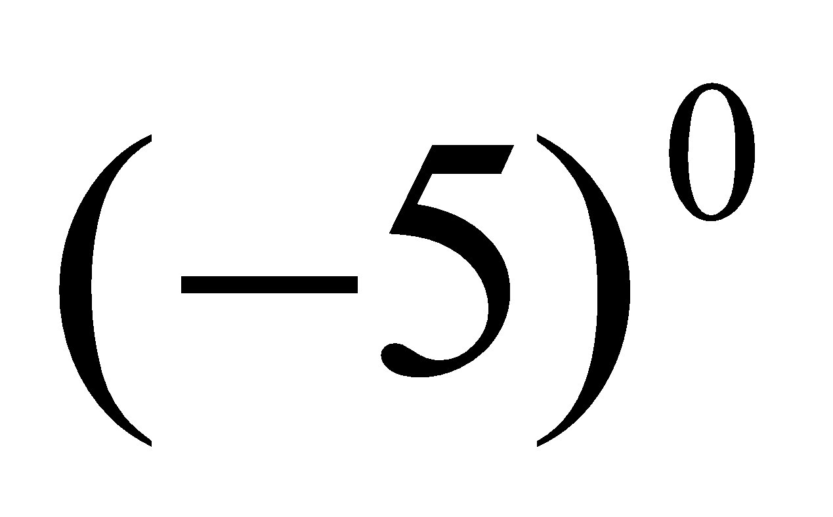

- Write as a power of ten. (1 mark each)

a) 1 b) 100 000

- Evaluate. (2 marks each)

a) 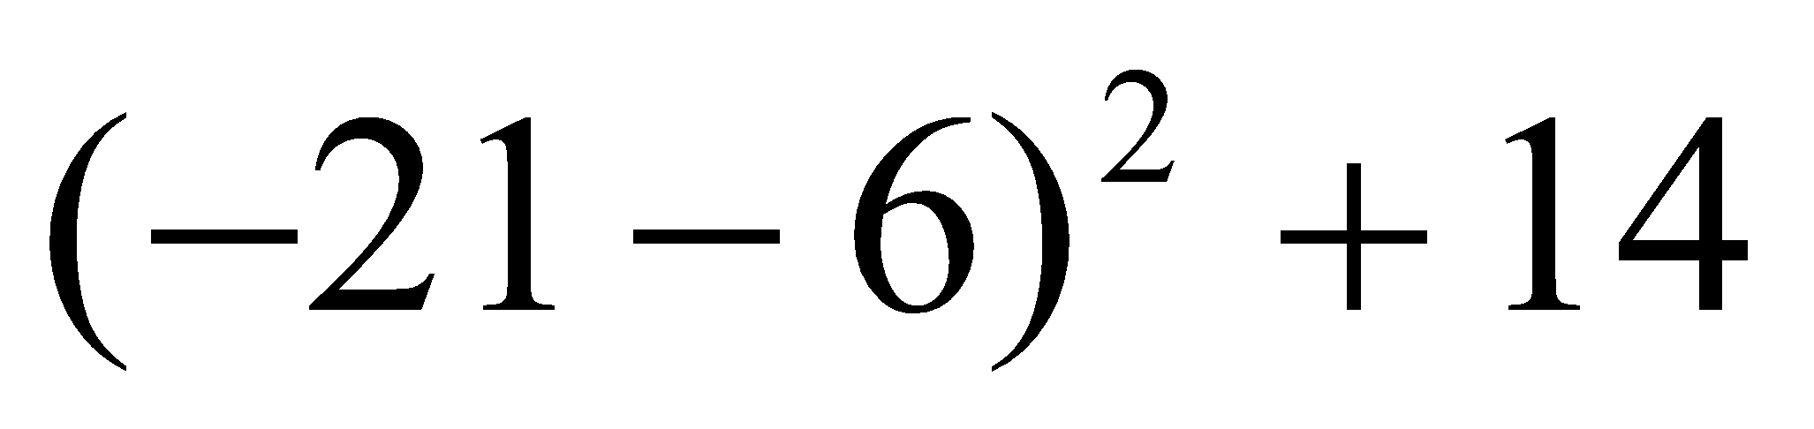 b) 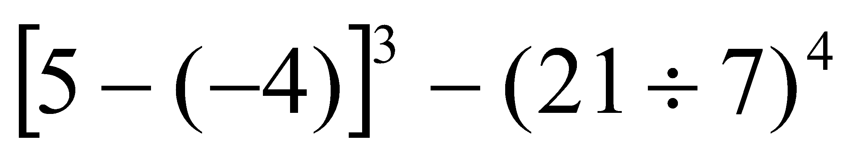

- Write each expression as a power. (1 mark each)

a) 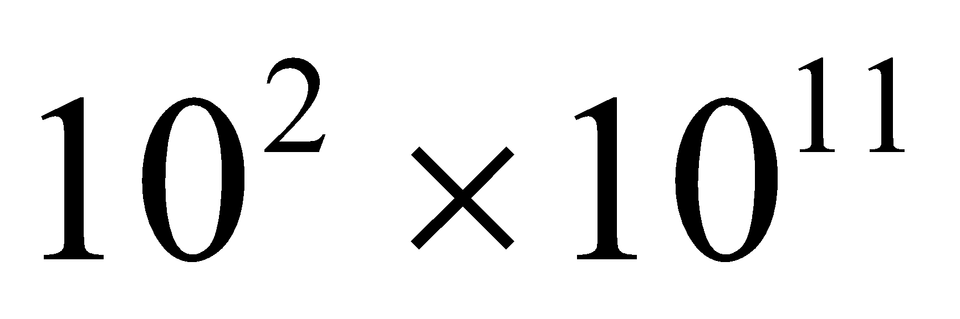 b) 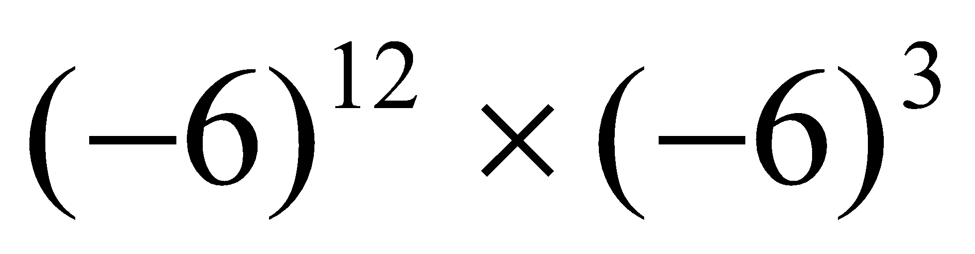

c) 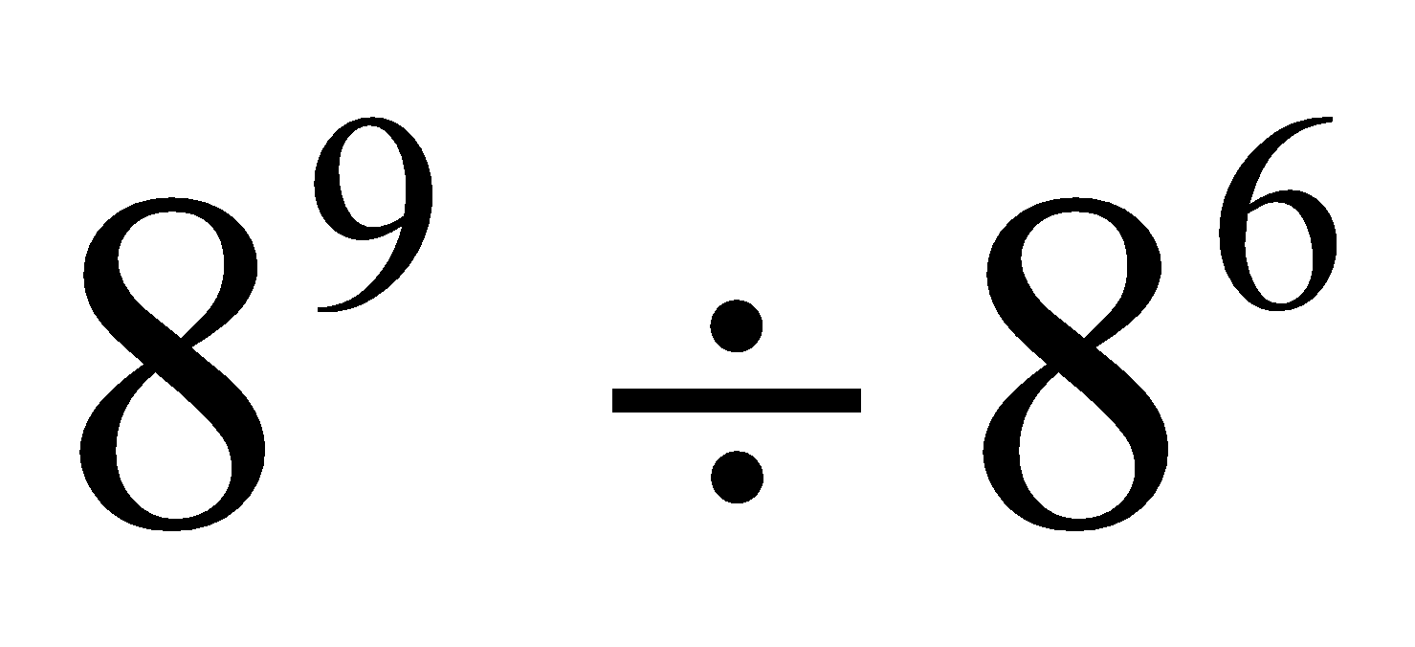 d) 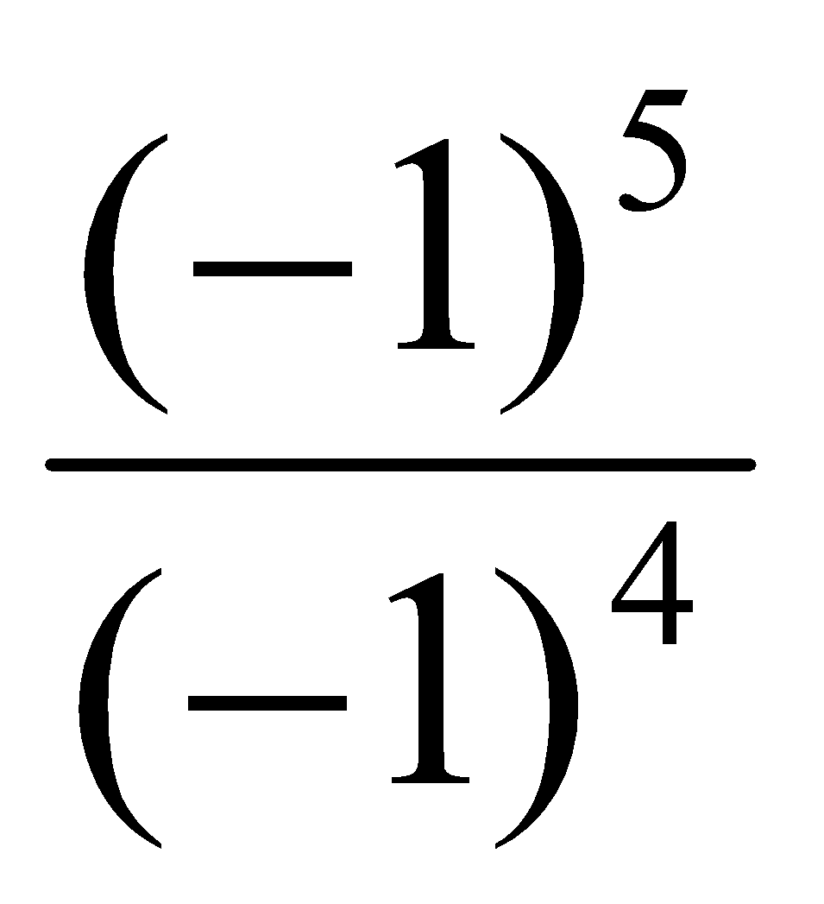

- Simplify, then evaluate. 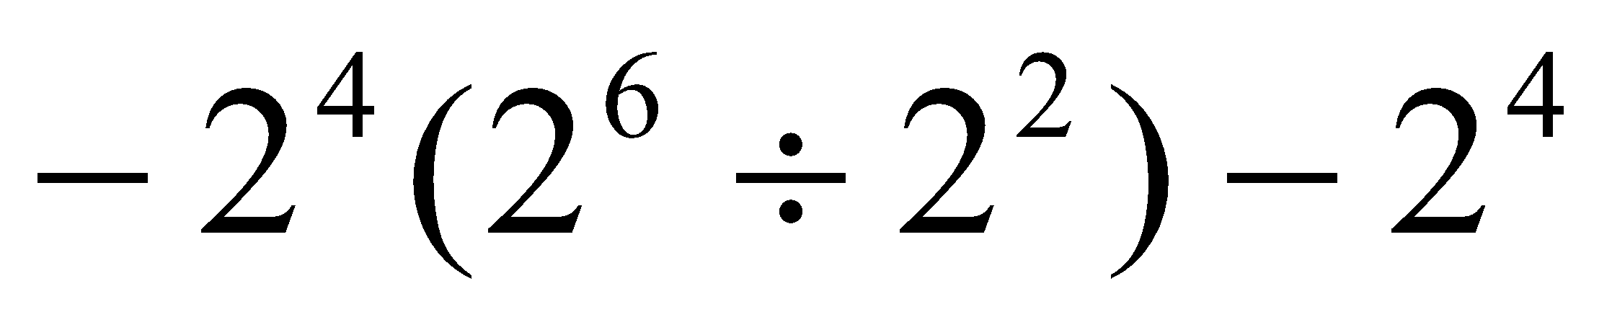 (2 marks)

- Write each expression as a product of powers. (1 mark each)

a) 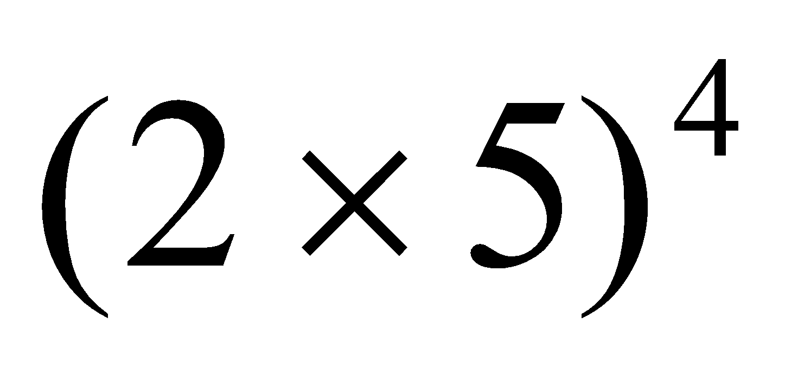 b) 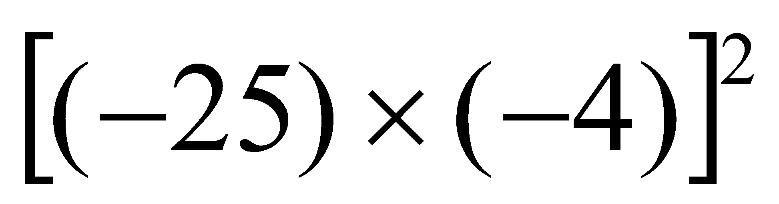

- Write each expression as a quotient of powers. (1 mark each)
a) 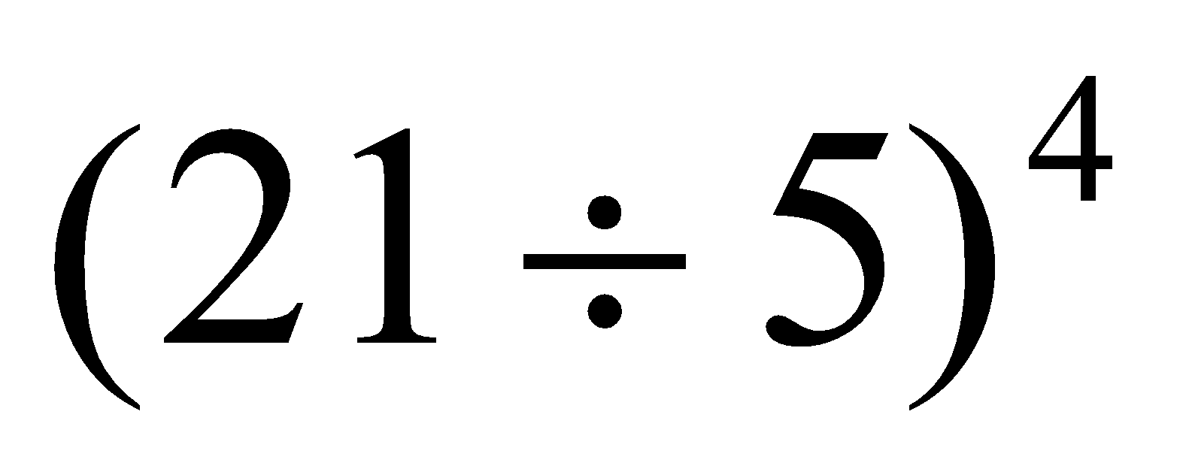 b) 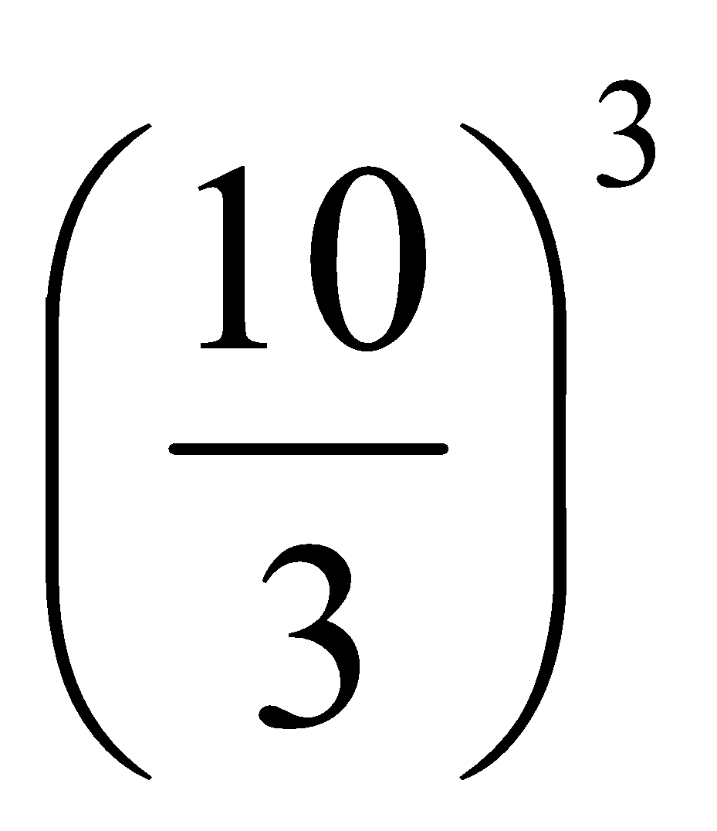

- Write as a single power. (1 mark each)

a) 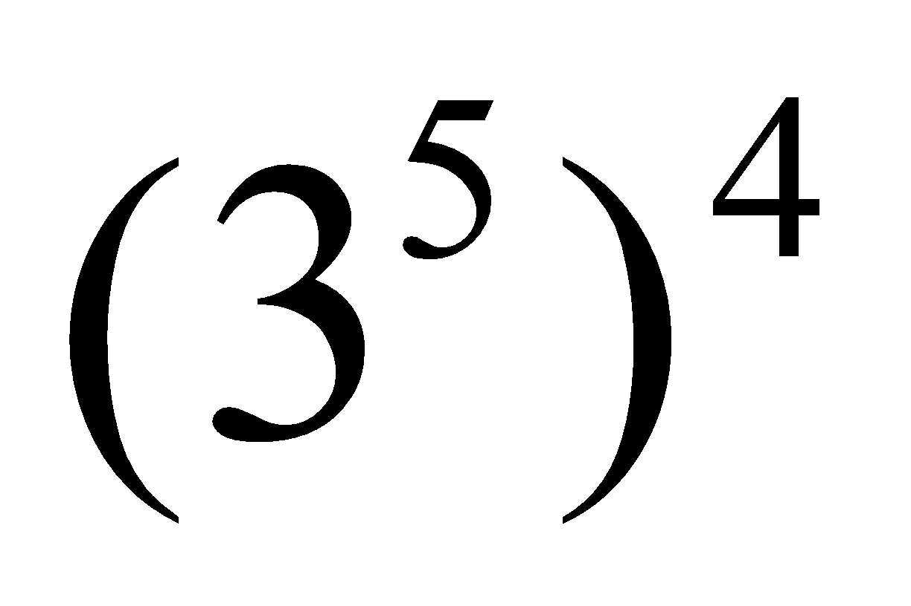 b) 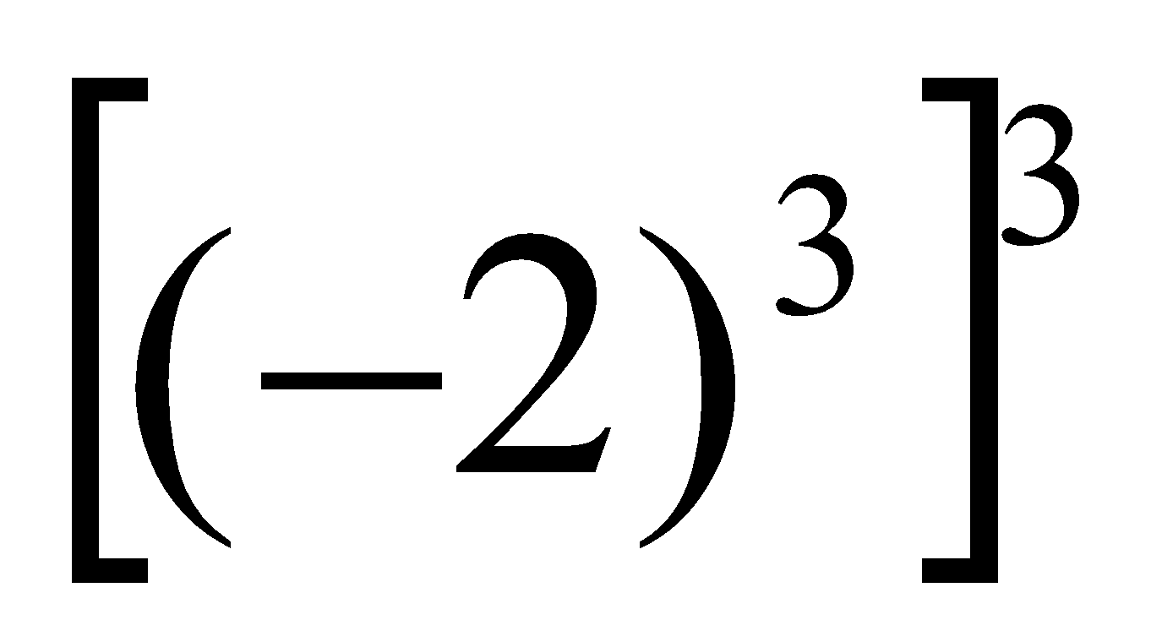

14. Simplify, then evaluate. (3 marks) 2³ – [(-2)⁴(-2)³ ÷ (-2)⁵]⁷ ÷ [(-2)⁴]³

15. The two bacteria that a microbiologist is studying reproduce at different exponential rates as long as conditions are appropriate. Sample A starts with just 50 bacteria. The population triples every hour. Sample B starts with 600 bacteria and doubles every hour.

- Create a chart to show the numbers of bacteria in each sample after 0 to 8 hours.

Time | 0 | 1 | 2 | 3 | 4 | 5 | 6 | 7 | 8
Sample A
Sample B

b) Write an expression to model the number of bacteria after a number of hours, n

for sample A

for sample B

c) How many bacteria will be present in sample A and sample B after 10 hours?

